Date of submission: 17th januray 2025
Batch: C1 Roll No.: 16010122323
Div: C
Student Name: Vedansh Savla
Experiment No: 1
Staff In-charge: Shivani Deosthale

TITLE: Encryption-Decryption using symmetric key
AIM: Encryption-Decryption programs using classical cryptography (Playfair cipher/Substitution cipher, Transposition cipher)
OUTCOME: Student will be able to
CO1: Explain various security goals, threats, vulnerabilities and controls
CO2: Apply various cryptographic algorithms for software security

______________________________________________________________________
Theory:

Algorithm 1:

Algorithm 2:

Program Implementation: 1)

def standardize_key(key):
# single case
key = key.upper()

# combine i and j
key = key.replace("J", "I")

# removing duplicate letters + maintaining order
standardized_key = ""
for char in key:
if char not in standardized_key and char.isalpha(): # ensuring its a letter
standardized_key += char

return standardized_key

def playfair_matrix(key):

# key = standardize_key(key)
alphabet = "ABCDEFGHIKLMNOPQRTSUVWXYZ" # no J

matrix = []
for char in key: # adding std_key to the matrix
if char not in matrix:
matrix.append(char)

for char in alphabet: # adding remainig letters to the matrix
if char not in matrix:
matrix.append(char)

playfair_matrix = []
for i in range(5):
playfair_matrix.append(
matrix[i * 5 : (i + 1) * 5]
) # matrix[0:5], matrix[5:10], matrix[10:15] and so on..

return playfair_matrix

def plaintext_pairs(plaintext):

plaintext = plaintext.upper()
plaintext_paired = []
i = 0

while i < len(plaintext):
letter1 = plaintext[i]
if i + 1 < len(plaintext):
letter2 = plaintext[i + 1]
if letter1 == letter2:
plaintext_paired.append(letter1 + "X")
plaintext_paired.append(letter2 + "X")
i = i + 2
else:
plaintext_paired.append(letter1 + letter2)
i = i + 2
else:
plaintext_paired.append(letter1 + "X")
i = i + 1

return plaintext_paired

def encrypt(letter1, letter2, pmatrix):
encrypted_pair = ""
row1, col1, row2, col2 = -1, -1, -1, -1
# Find positions of the two letters
for i, row in enumerate(pmatrix):
if letter1 in row:
row1, col1 = i, row.index(letter1)
if letter2 in row:
row2, col2 = i, row.index(letter2)

# Same row
if row1 == row2:
encrypted_pair = pmatrix[row1][(col1 + 1) % 5] + pmatrix[row2][(col2 + 1) % 5]

# Same column
elif col1 == col2:
encrypted_pair = pmatrix[(row1 + 1) % 5][col1] + pmatrix[(row2 + 1) % 5][col2]

# Rectangle rule
else:
encrypted_pair = pmatrix[row1][col2] + pmatrix[row2][col1]

return encrypted_pair

# key
key = input("Enter the key (e.g., 'KEYWORD'): ")
skey = standardize_key(key)
print(f"The standardized key is: {skey}")

# making matrix 5x5
pmatrix = playfair_matrix(skey)

# print(pmatrix)
print("The Playfair matrix is:") # printing the matrix w/o [,]
for row in pmatrix:
print(" ".join(row))

# taking the plaintext from user
plaintext = input("Enter the plaintext: ")
# print({plaintext})

# dividing the plaintext into pairs of two letters:
prepared_text = plaintext_pairs(plaintext)
print(prepared_text)

# Encrypting the prepared plaintext pairs
encrypted_text = ""
for pair in prepared_text:
letter1, letter2 = pair[0], pair[1] # Extract each pair of letters
encrypted_text += encrypt(
letter1, letter2, pmatrix
) # Encrypt the pair and append to the result

print("The encrypted text is:", encrypted_text)

Output(s):
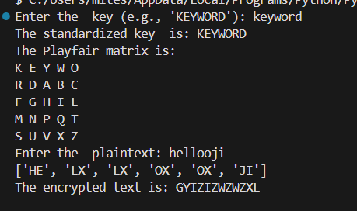

Program Implementation: 2)
def caesar_cipher(text, shift):
shift = shift % 26
result = ""

for char in text:
if char.isalpha():
shift_base = 65 if char.isupper() else 97
new_char = chr((ord(char) - shift_base + shift) % 26 + shift_base)
result += new_char
else:
result += char

return result

def main():
try:
text = input("Enter the text to be encrypted: ")
shift = int(input("Enter the shift value: "))

encrypted_text = caesar_cipher(text, shift)
print(f"Encrypted Text: {encrypted_text}")

decrypted_text = caesar_cipher(encrypted_text, -shift)
print(f"Decrypted Text: {decrypted_text}")

except ValueError:
print("Error: Please enter a valid integer for the shift value.")
except Exception as e:
print(f"An error occurred: {e}")

if __name__ == "__main__":
main()

Output(s):

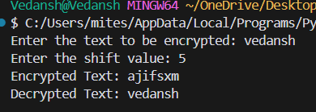
Post Lab Questions:
1. Encryption Decryptions (with screen shots of virtual lab)
Virtual Laboratory Experiments- (http://cse29-iiith.vlabs.ac.in/)

a. Breaking the Shift Cipher

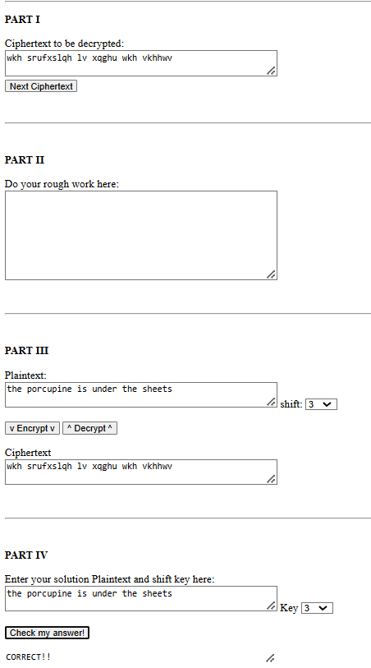

b. Breaking the Mono-alphabetic Substitution Cipher
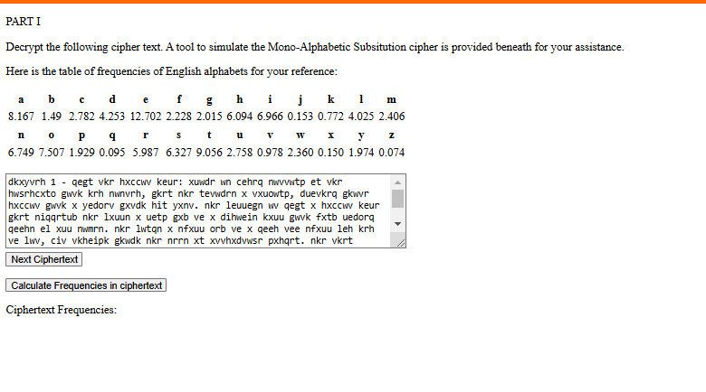
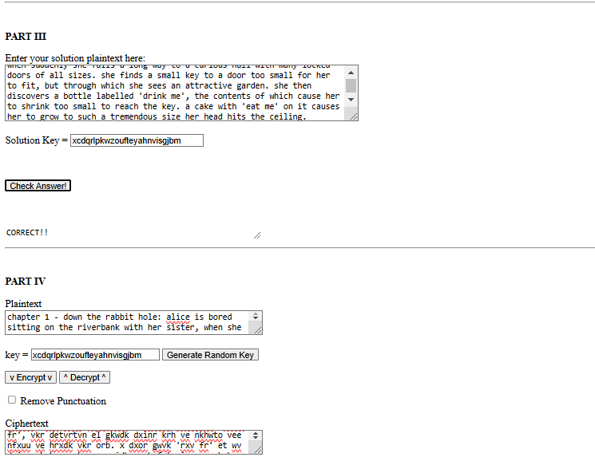

2. Explain Hill cipher with example and implement program.
The Hill cipher is a polygraphic substitution cipher based on linear algebra. It uses matrix multiplication to encode plaintext, making it a secure and systematic encryption method.

Steps to Understand Hill Cipher:
- Key Concept:
  - A square matrix acts as the encryption key.
  - Each letter of the alphabet is assigned a numerical value: A=0,B=1,…,Z=25A=0, B=1, \dots, Z=25A=0,B=1,…,Z=25.
  - The plaintext is divided into blocks of size equal to the matrix dimension.
- Encryption:
  - Multiply each block of plaintext (represented as a vector) by the key matrix.
  - Reduce each element of the resulting vector modulo 26 to map it back to letters.
- Decryption:
  - The decryption key is the inverse of the key matrix modulo 26.
  - Multiply the ciphertext vector by the inverse key matrix and take modulo 26.
- Matrix Requirements:
  - The key matrix must have an inverse modulo 26. This means its determinant (mod 26) must be coprime to 26.
import numpy as np

# Convert a character to its numeric equivalent
def char_to_num(char):
return ord(char.upper()) - ord('A')

# Convert a number to its character equivalent
def num_to_char(num):
return chr(num + ord('A'))

# Encrypt using Hill Cipher
def hill_encrypt(plaintext, key_matrix):
n = len(key_matrix)
plaintext = plaintext.upper().replace(" ", "")

# Padding if necessary
if len(plaintext) % n != 0:
plaintext += 'X' * (n - len(plaintext) % n)

# Convert plaintext to numeric blocks
blocks = [plaintext[i:i+n] for i in range(0, len(plaintext), n)]
ciphertext = ""

for block in blocks:
vector = np.array([char_to_num(c) for c in block])
result = np.dot(key_matrix, vector) % 26
ciphertext += ''.join(num_to_char(int(num)) for num in result)

return ciphertext

# Decrypt using Hill Cipher
def hill_decrypt(ciphertext, key_matrix):
n = len(key_matrix)
determinant = int(round(np.linalg.det(key_matrix)))
determinant_inv = pow(determinant, -1, 26)
key_inv = determinant_inv * np.round(determinant * np.linalg.inv(key_matrix)).astype(int) % 26

# Convert ciphertext to numeric blocks
blocks = [ciphertext[i:i+n] for i in range(0, len(ciphertext), n)]
plaintext = ""

for block in blocks:
vector = np.array([char_to_num(c) for c in block])
result = np.dot(key_inv, vector) % 26
plaintext += ''.join(num_to_char(int(num)) for num in result)

return plaintext

# Example usage
key = np.array([[6, 24], [1, 13]])
plaintext = "HELLO"
ciphertext = hill_encrypt(plaintext, key)
decrypted_text = hill_decrypt(ciphertext, key)

print("Plaintext:", plaintext)
print("Ciphertext:", ciphertext)
print("Decrypted Text:", decrypted_text)

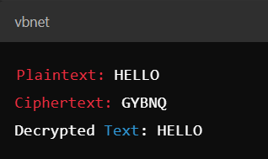

Conclusion: This experiment introduced and implemented classical cryptographic techniques, including the Playfair cipher, Caesar cipher, and Hill cipher. By exploring their theoretical foundations and practical applications, we gained insights into how symmetric key encryption ensures data security.
Through the Playfair cipher, we observed the construction and utilization of a 5x5 key matrix for encryption. The Caesar cipher demonstrated the simplicity and flexibility of shift-based substitution encryption. Finally, the Hill cipher showcased the application of linear algebra in cryptography, highlighting the importance of matrix operations for secure encryption and decryption.
These exercises enhanced our understanding of:
- Key concepts of symmetric cryptography, such as substitution and transposition.
- The importance of modular arithmetic and matrix inversion in cryptographic algorithms.
- Practical implementation techniques for securing communication.
By mastering these classical methods, we have established a strong foundation for exploring modern cryptography and its applications in software security. This understanding aligns with the course outcomes by enabling us to identify security threats and implement cryptographic solutions effectively.

